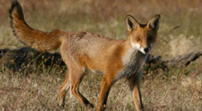
FOX BAITING 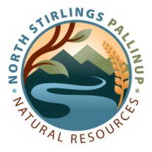
Expression of Interest : Calling for Rural Property Owners / Managers / Lessees
in the Shire of Gnowangerup and neighbouring areas who may be interested in Fox Baiting
(including existing RP 1080 bait permit holders).
1080 Baits Devolved Grant Program
This project will SUPPLY the baits for the following baiting period on the condition that YOU lay them.
During Summer/Autumn 2024
To apply and participate in this project, fill in the box below and return this form to:
Laura Page laura@nspnr.com.au 0401 553 285 Due: 15 April 2023
Applicant | Owner or Manager or Lessee
 | Postal Address:
 | Email Address:
 | Phone:
Property  Proposed to be Baited | Please Circle: | Private / Public Local / State / Federal
 | Shire:
 | ABN:
 | Registered or Trading Name:
 | Physical Address (must include a road):
 | Lot/s (please attach a map):
 | Indicate on map any areas that could support chuditch, Malleefowl or Carneby's Black Cockatoo. eg remnant bushland, remnant Malleefowl areas, active Malleefowl mounds
Livestock at Risk from Foxes | Sheep: No. Ewes and No. Lambs (or none):
 | Other Stock: Type and number (or none):
 | Closest Neighbour Property Sheep (Kms):
 | Closest Neighbour Property Other Stock:
Existing RP Permits | Already have a bait permit: | YES / NO
 | If Yes, provide the RP Permit Number and expiry date:
Tasks I Will Do | I will attend a day of 1080 accreditation and apply for an PR permit (DPIRD currently $83.50 GST inc) | YES / NO
 | I will lay all baits during the period | YES / NO
 | I will provide monitoring data (including baits NOT taken): | YES / NO
 | Number of baits requested
Please fill in a separate form for each applicant type below

